**1.Title: Online Restaurant Management**



**2.Project Statement:**

The project aims to develop a user-friendly web application that facilitates and the aim of this project is to develop an online restaurant management system which is easily accessible to the customers. We propose to build a software project that can efficiently handle and manage various activities of a restaurant and all these activities will be happening under the supervision of the administrator. The main objective is to design a Restaurant table booking and managing system effectively.

l**Outcomes:**

The businesses in restaurants will grow constantly. At the same time, the need for managing its operations and tasks arises. The best way to optimize these activities is growing the business online as well. Enhance patient satisfaction by offering a seamless and user-friendly interface.

1. **Modules to be implemented**
2. User Authentication and Registration
3. Appointment Scheduling Interface
4. Table Availability Management
5. Menu Information Management
6. Table Booking Management
7. Notification System
8. Admin Dashboard
9. **Week-wise module implementation and high-level requirements with output screenshots**

**Milestone 1: Weeks 1-3**

**Module 1: User Authentication and Registration**

* Implement user registration functionality.
* Develop user login mechanism.
* Integrate email verification and password reset features.
* Output screenshoot:

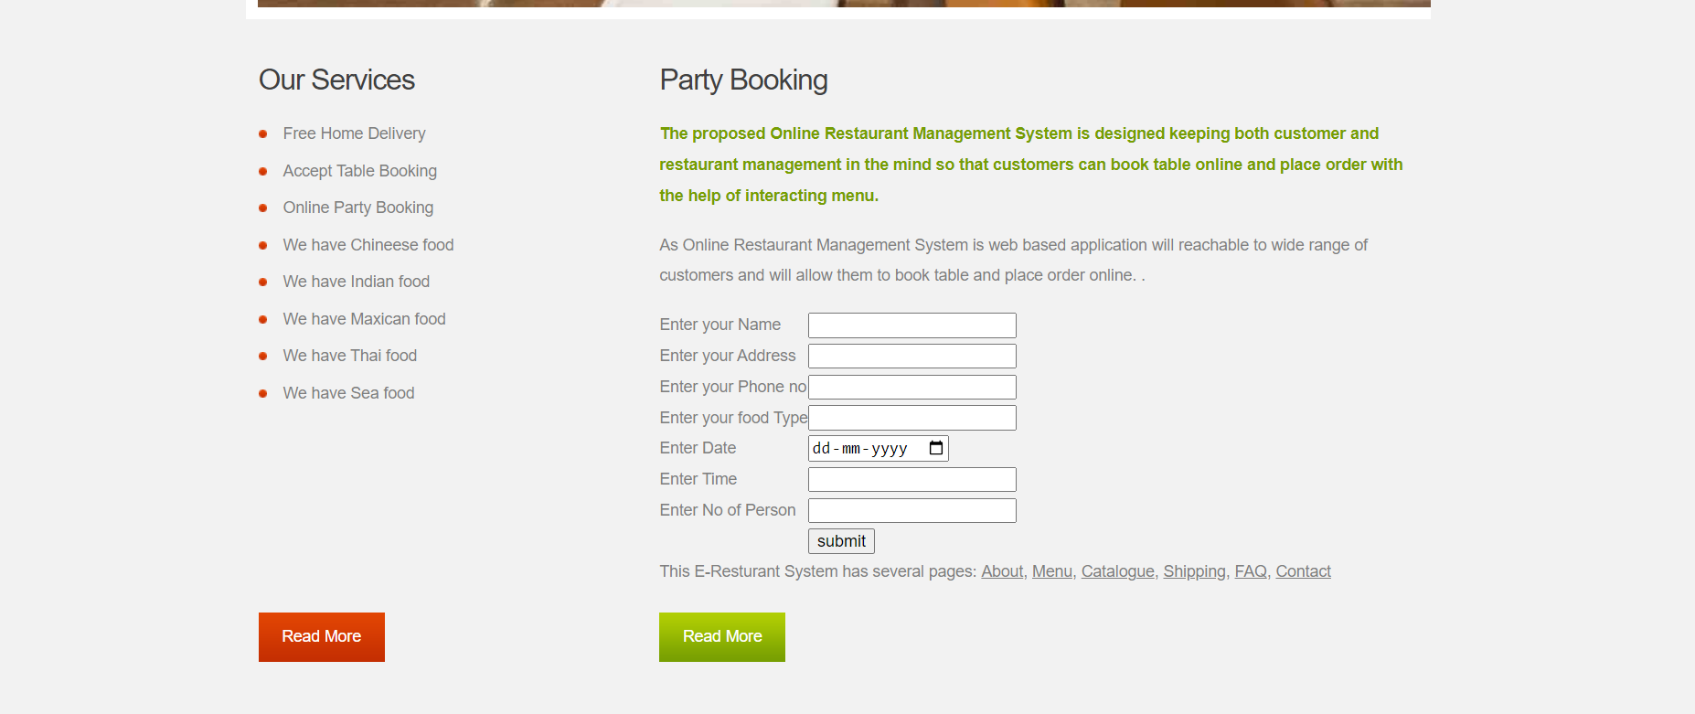

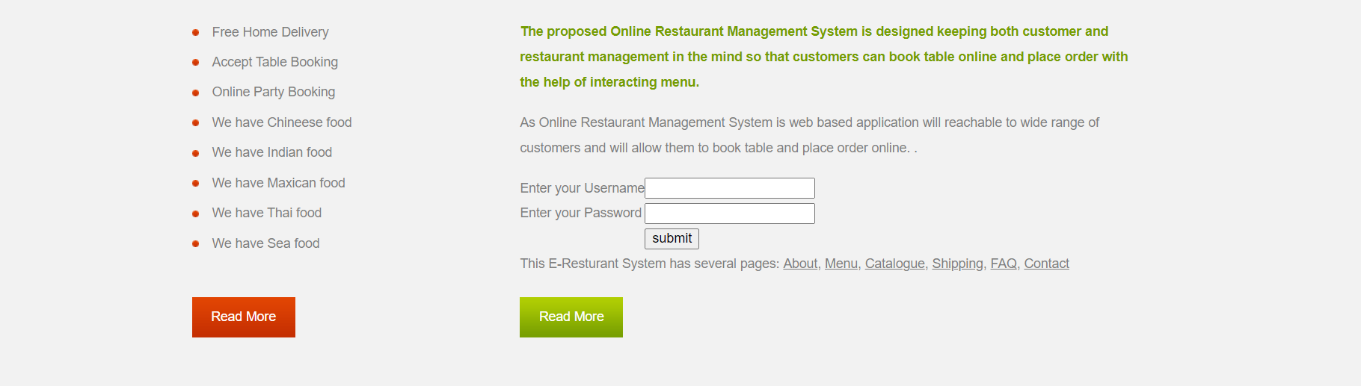

**Module 2: Table Availability Management**

* Design database schema for storing table availability information.
* Develop an interface for table management to set their availability.
* Implement backend functionality to manage and update doctor availability.
* Output screenshot

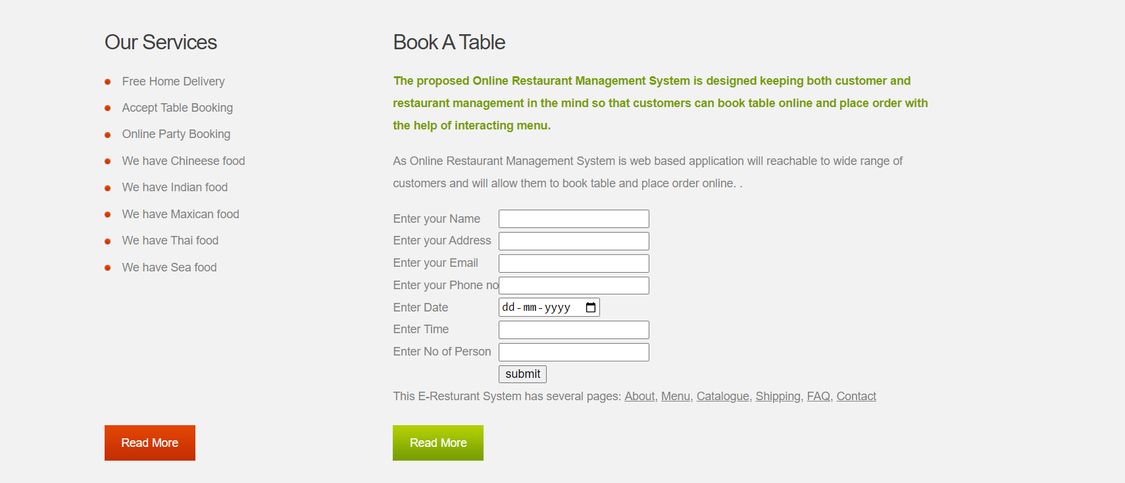

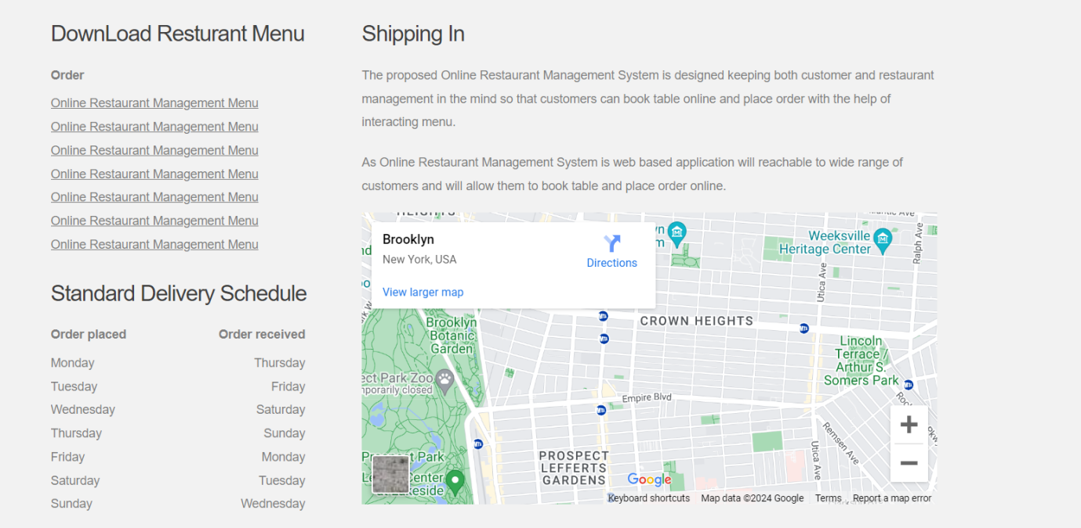

**Milestone 2: Weeks 4-5**

**Module 3: Menu Information Interface**

* Design and develop the interface for Menu Information.
* Implement functionality for users to select menu, preferred time slots.
* Integrate the scheduling interface with the backend for storing table appointment details.
* Output screenshot

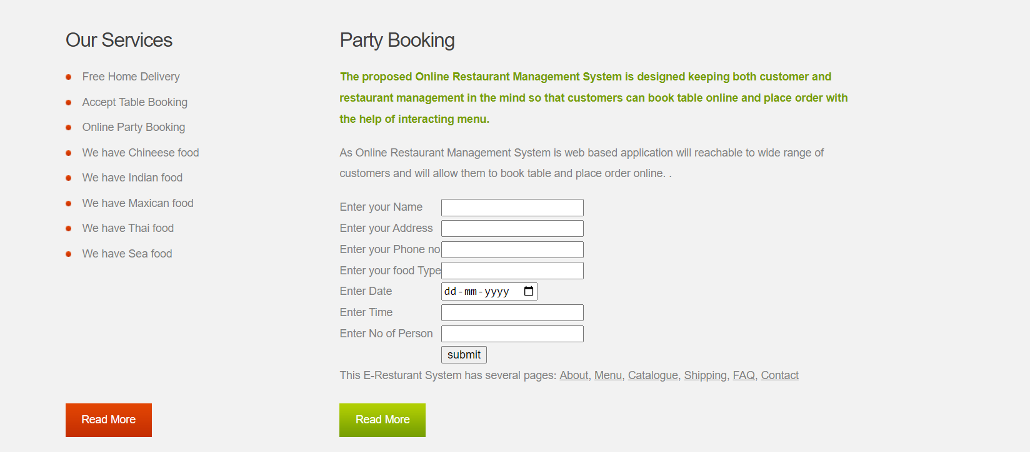

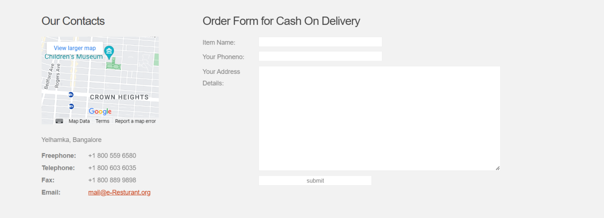

**Milestone 3: Weeks 6-7**

**Module 4: Menu Information Management**

* Design database schema for storing appointment details.
* Implement backend functionality for scheduling table booking and preventing conflicts.
* Develop an interface for doctors and patients to view and manage appointments.
* Output Screenshot:

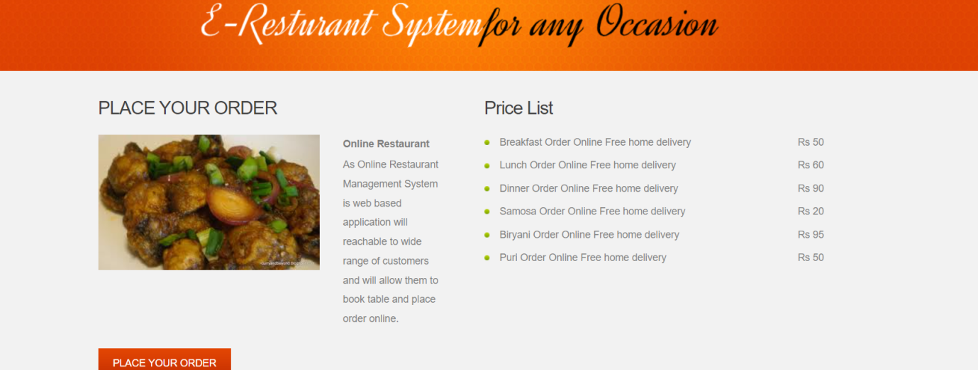



**Milestone 4: Weeks 8-10**

**Module 5: Table Information Management**

* Design database schema for storing customer information .
* Develop functionality for customer to provide and update their information.
* Implement backend logic for accessing and managing customer information securely.
* Output Screenshot:

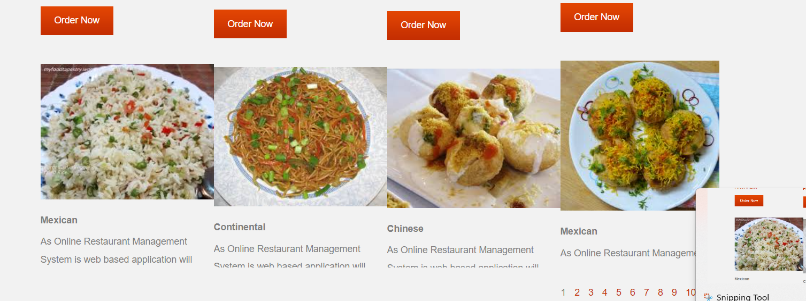

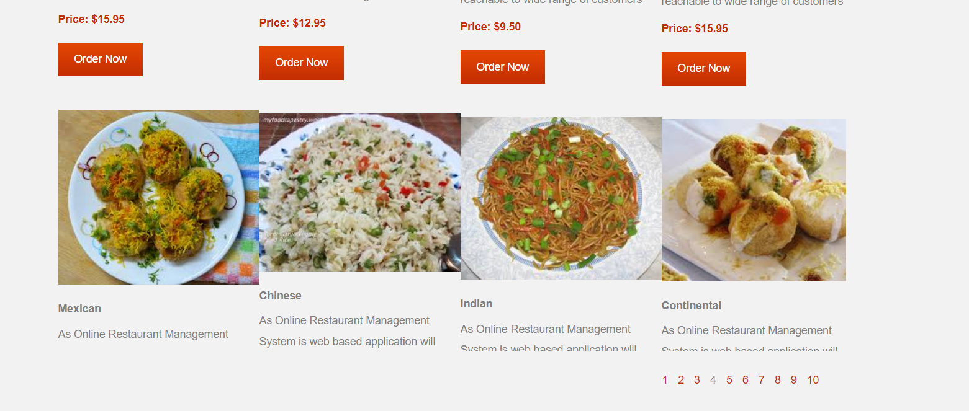

**Module 6: Notification System**

* Integrate email and/or SMS notification services.
* Develop triggers and notifications for appointment reminders, new bookings, and cancellations.
* Implement a system for handling and tracking notifications.
* Output screenshot:

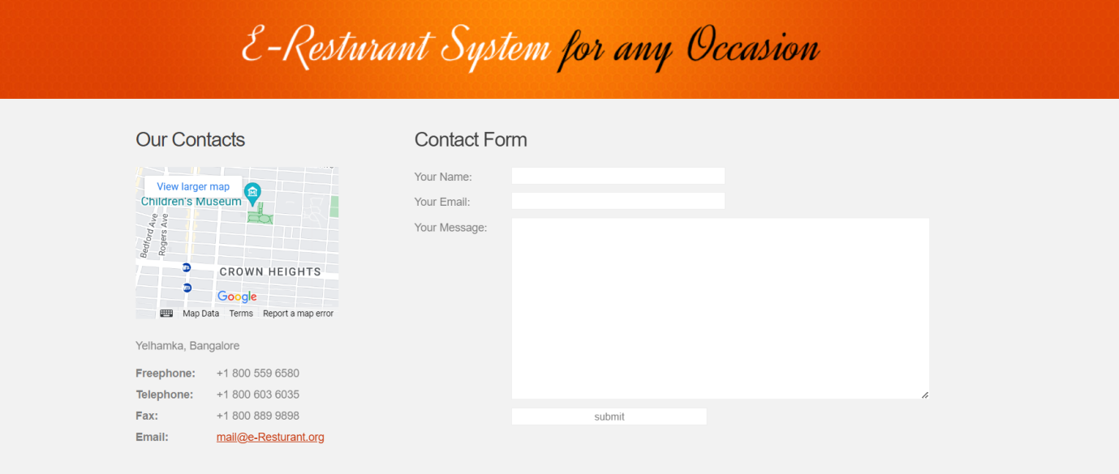

**Module 7: Admin Dashboard**

* Design the layout and functionality of the admin dashboard.
* Implement user management features for admins to add, edit, and delete users.
* Develop modules for managing doctors, appointments, and patient information.
* Output Screenshot:

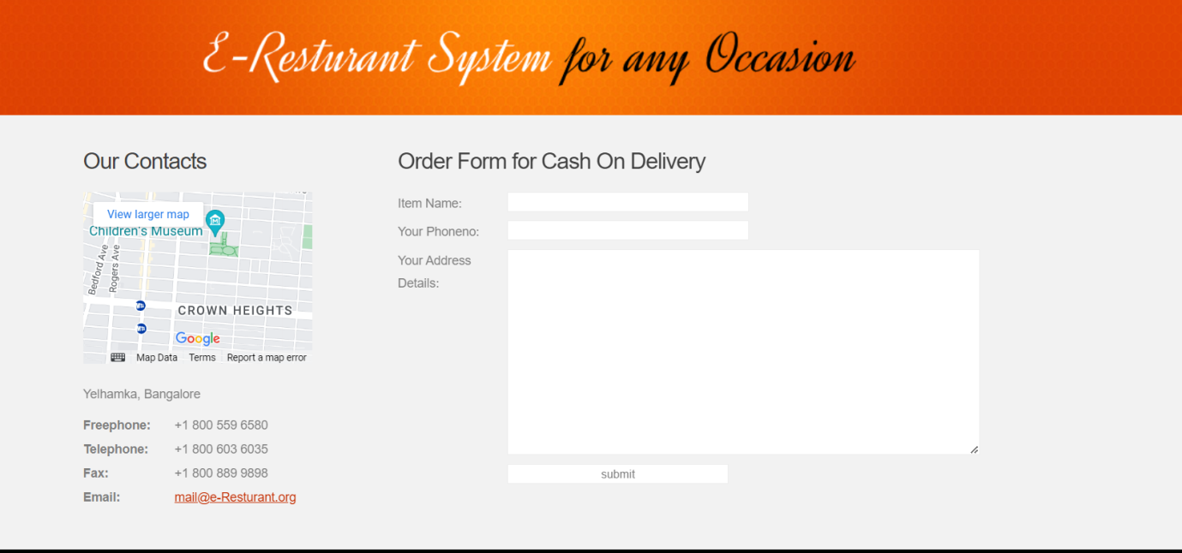

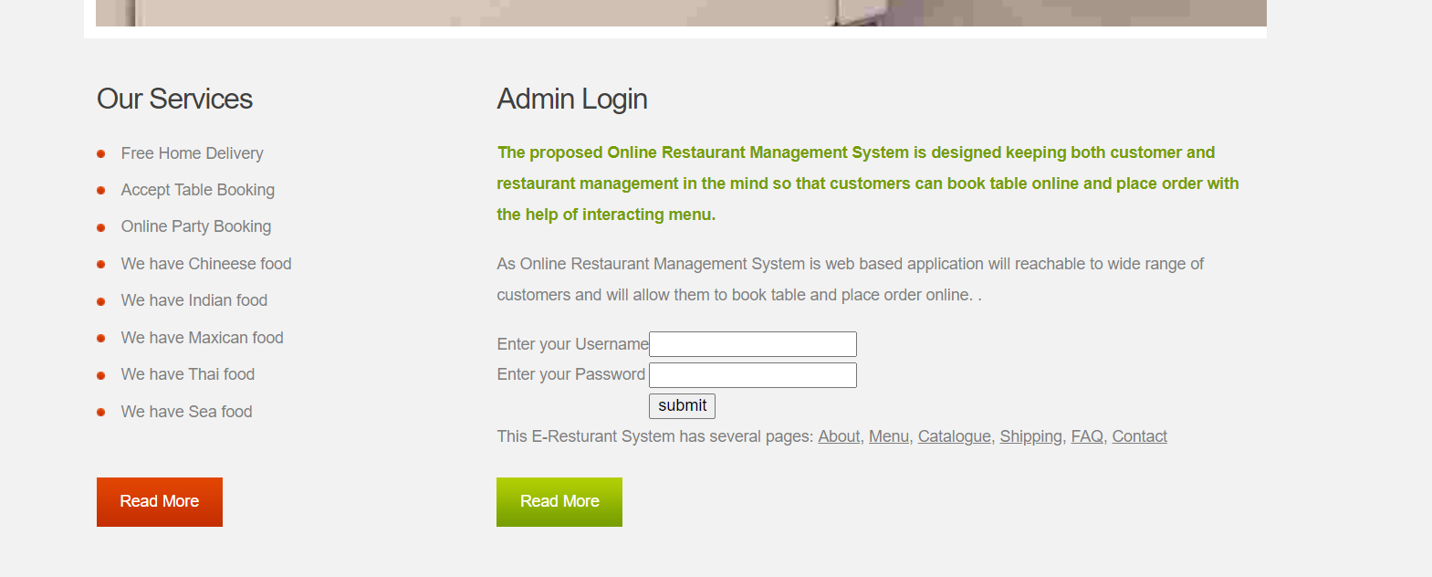

**Evaluation Criteria:**

**Milestone 1 Evaluation (Week 3):**

* Completion of user authentication and registration.
* Successful implementation of table availability management functionalities.

**Milestone 2 Evaluation (Week 5):**

* Appointment scheduling interface is fully developed and integrated with the backend.

**Milestone 3 Evaluation (Week 7):**

* Appointment management system is operational, allowing for scheduling and viewing table booking.

**Milestone 4 Evaluation (Week 10):**

* Customer information management, notification system, and admin dashboard are fully implemented and functional.

1. Design diagrams

Class Diagram: Entity classes

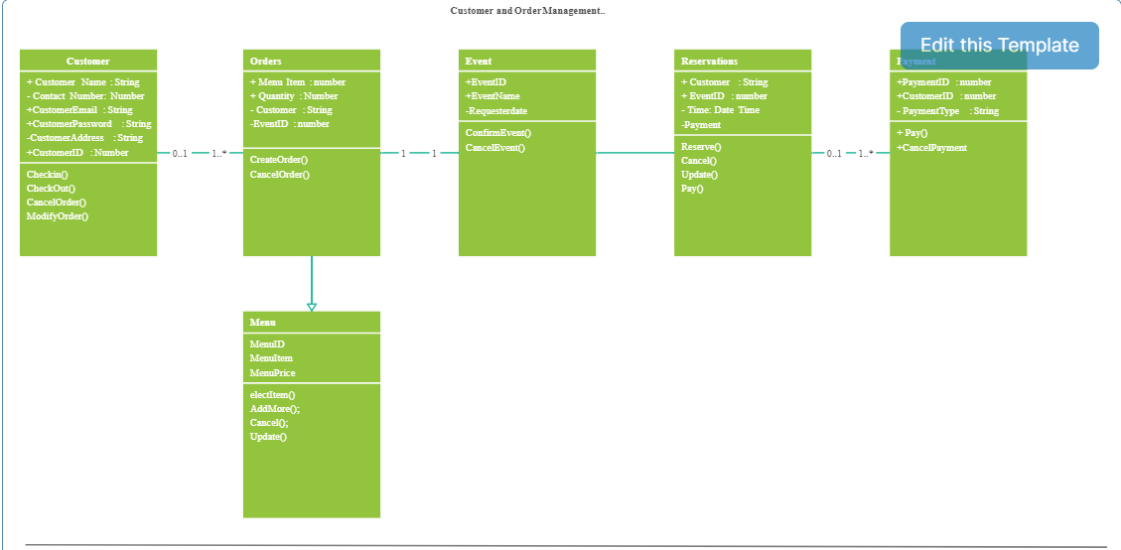

**Output Screenshots:**

1. Dashboard



2. Admin Dashboard

